**Relational Database Systems -Assignment 2**

Contents

Task1-Report 2

Task 2- Database Design 3

2.a) ERD and Data Dictionary 3

I. Entity Relationship Diagram-ERD 3

II. Data Dictionary 4

2.b) Normalization 4

I. 1st Normal Form 4

II. 2nd Normal Form 6

III. 3rd Normal Form 6

2.c) Security and Data Integrity Features 7

I. Data integrity 7

II. Security controls and DBA roles 7

Task 3- Report 8

3.a) Relationship diagram 8

3b) Normalization and Functional dependency 8

Normalization 8

Functional dependency 8

1st Normal Form 8

2nd Normal Form 9

3rd Normal Form 9

3c) Integrity Constraints 10

3.d) Data integrity and Security controls 11

3e) how the design documents meet the design brief? 11

3.f) Database Evaluation 12

References 14

**2B) check and 1b)**

# Task1-Report

1.a) an explanation of database management systems

Database

Database Management System

Applications of DBMS

1.b) an explanation of the different levels of database architecture

3 Levels- Internal Conceptual External & Diagram

1.c) a description of big data and how it can apply to the database management system

Big Data

3V’s Velocity, Variety, Volume

Applications of Big data

1.d) an explanation of transaction processing within a database management system

Transaction definition,

Transaction Properties (ACID),

Transaction States (Put diagram too),

Transaction Manager (Diagram and one line each)

OLTP OLAP (One line definitions+ Differences between the two)

1.e) an evaluation of the importance of data integrity and quality control within a management

system

GIGO

Data Integrity Definition.

Integrity Importance

Data Quality

# Task 2- Database Design

## 2.a) ERD and Data Dictionary

### Entity Relationship Diagram-ERD

* **Identifying Entities and their attributes**

*(adjectives/nouns that describe the entities)*

There are *nmbr* Entities in the database:

Entity 1 (***)

It has * fields with * being the primary key

Attribute1- 1 line description

Attribute2- 1 line description

Attribute3- 1 line description

Entity 2 (Customer)

It has * fields with * being the primary key

Attribute1- 1 line description

Attribute2- 1 line description

…….

Entity 3 (Sales)

It has * fields with * being the primary key

Attribute1- 1 line description

Attribute2- 1 line description

* **Identify the relationships**

*Entity1 relatingverb Entity2*

*(e.g: Customer* ***buys*** *Product, Staff* ***sells*** *Product)*

* **Mapping**

*Find number of instances (M) of each entity related to how many instances(N) of other entity.*

*Example:*

*One Customer can place many orders.*

*One order can be placed by One Customer only.*

* **Entity Relationship Diagram for the scenario**

*Draw the ERD using Microsoft Word [Insert->Shapes].*

### Data Dictionary

*Data Dictionary Description*

|  |  |  |  |  |
| --- | --- | --- | --- | --- |
| **Table 1 Customer** | | | | |
| **Field** | **Optional** | **Format** | **Length Limit** | **Description** |
| Customer_ID | N | NUMBER | - | Primary key |
| Customer_name | N | TEXT | 50 | **-** |
| Gender | Y |  |  | - |
|  |  |  |  |  |
|  |  |  |  |  |

|  |  |  |  |  |
| --- | --- | --- | --- | --- |
| **Table 2 \*\*\*\*\*\*\*\*** | | | | |
| **Field** | **Optional** | **Format** | **Length Limit** | **Description** |
|  |  |  |  | Primary key |
|  |  |  |  | Foreign key |
|  |  |  |  | **-** |
|  |  |  |  | - |
|  |  |  |  |  |

## 2.b) Normalization

### 1st Normal Form

*Consider one table at a time.*

**Consider Customer Table,**

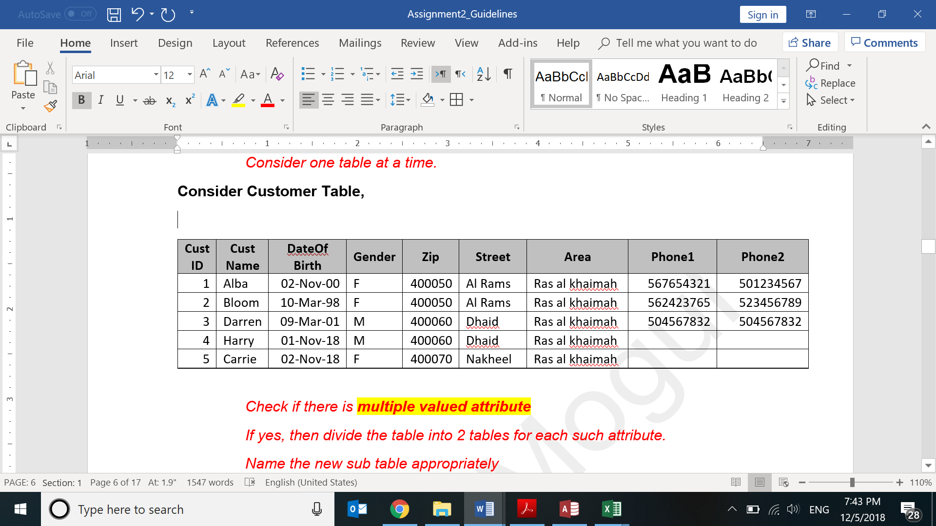

*Check if there is* ***multiple valued attribute***

*If yes, then divide the table into 2 tables for each such attribute.*

*Name the new sub table appropriately*

Customer table was not in 1NF as it had multivalued attribute-CustPhone

so it decomposes into Customer table and **Customer_Contact table**

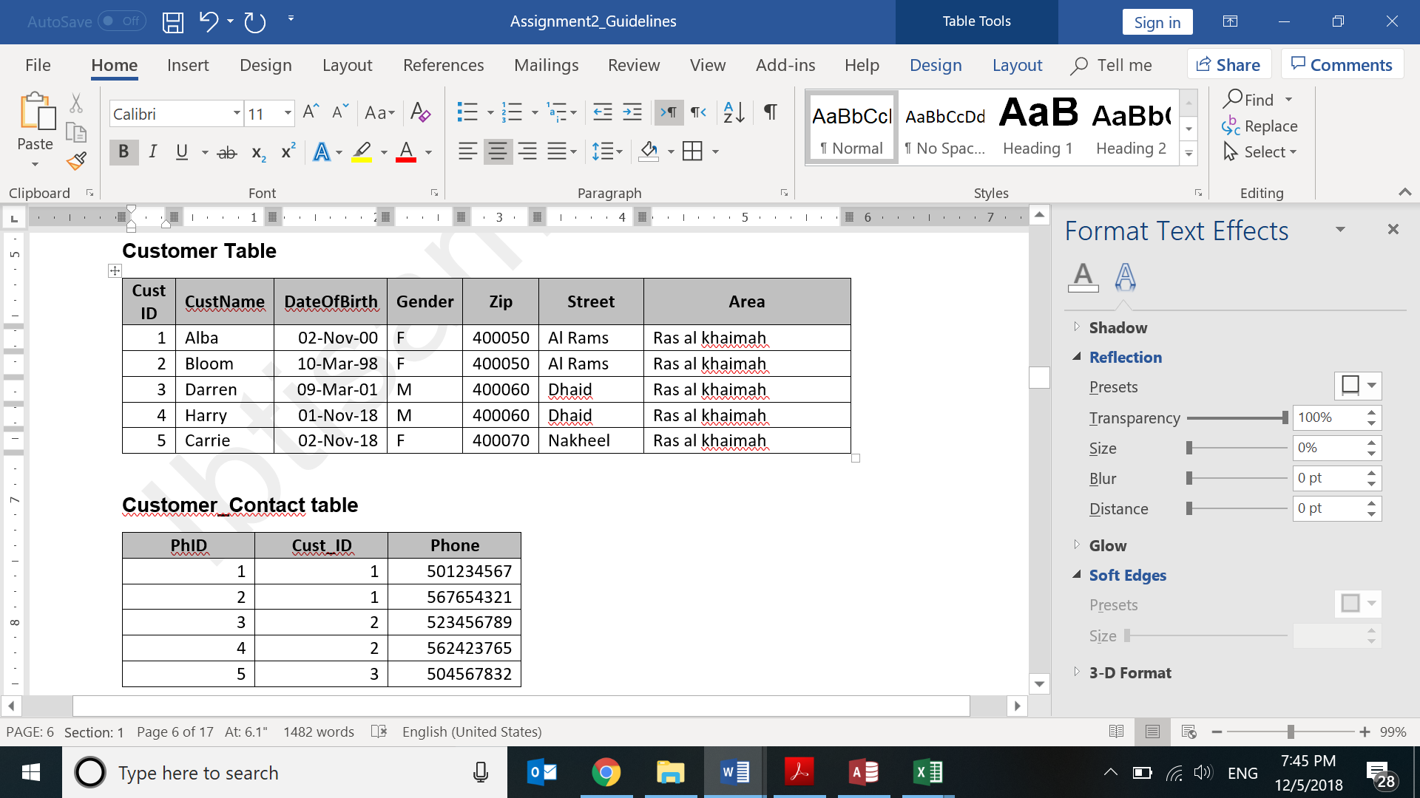

Now both tables are in 1NF.

***Repeat this procedure for other tables too***

**Consider Sales Table,**

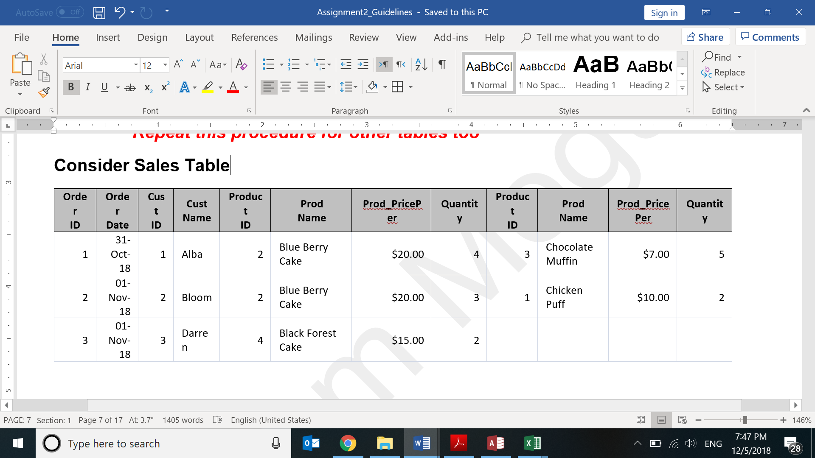

### 2nd Normal Form

*Consider one table at a time.*

*Check if there is any* ***partial dependency***

*If yes, divide the table into 2 tables for each such attribute.*

*Name the new sub table appropriately*

*Final statements for each table:*

*This table is in 2 NF as it is in 1 NF and there is no partial dependency.*

*OR*

*Table-name table is not in 2NF as it is in 1 NF but partial dependency exists*

*so it decomposes into Table-name1 and Tablename2.*

*Now both tables are in 2NF*

***Repeat this procedure for newly created tables and other tables too***

### 3rd Normal Form

*Follow procedure like above.*

*Result statements for each table:*

*This table is in 3 NF as it is in 2 NF and there is no transitive dependency.*

*OR*

*Table-name table is not in 3NF as it is in 2 NF but transitive dependency exists*

*so it decomposes into Table-name1 and Tablename2.*

*Now both tables are in 3NF*

***Repeat this procedure for newly created tables and other tables too***

## 2.c) Security and Data Integrity Features

### Data integrity

**Entity Integrity**

**Null Rule**

If you did not enter anything in Cust Number you’ll get a null value and an error will appear.

**Unique Column**

**Primary Key**

The primary key in the Customer table Is Cust_ID

**Domain integrity**

**Data Type**

data type of Sale_ID is Number while Name is short text and etc.

**Referential Integrity Rules**

Customers_ID (primary key) in Customers table is the foreign key in the *** table.

### Security controls and DBA roles

*Definition of Security*

*DBA roles*

DAC [ GRANT / REVOKE] , MAC, RBAC

# Task 3- Report

## 3.a) Relationship diagram

*Description of ERD with Symbol explanation*

**Relationships within the database**

* *Describe relationship.*
* *Goto-> Database Tools-> Relationships tab: Click Printscreen(PrtSc)*

*paste in paint, crop desired part. Paste here. (Display screenshot)*

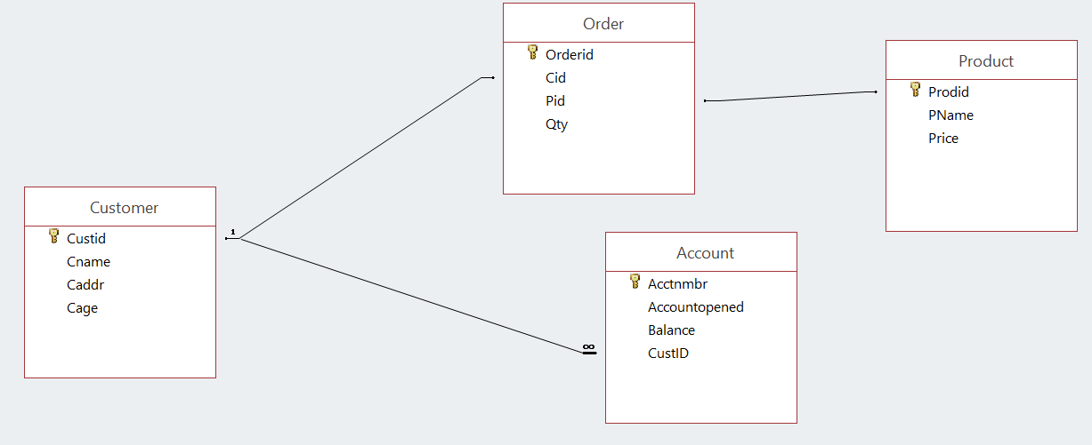

## 3b) Normalization and Functional dependency

### Normalization

*Describe Normalization*

### Functional dependency

*Description*

### 1st Normal Form

*Describe*

### 2nd Normal Form

*Describe*

### 3rd Normal Form

*Describe*

*Consider 1 table at a time. Describe which keys determines which attributes representing in below format. Check redundancies and remove.*

**Customers Table**

cust_ID -> customer_Name, contact_Number, Gender, Zipcode, Street, Emirate,

Phone1, Phone2

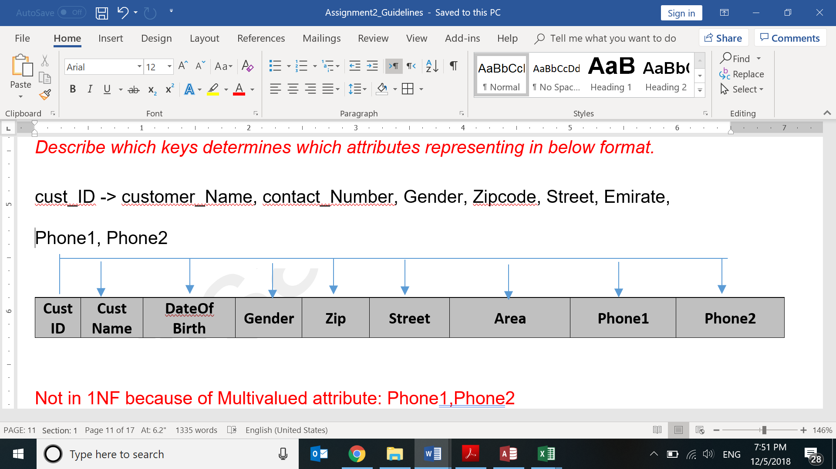

Not in 1NF because of Multivalued attribute: Phone1, Phone2

So decomposed into 2 tables: Customer and Cust_contact

Customer:

cust_ID -> customer_Name, contact_Number, Gender, Zipcode, Street, Emirate

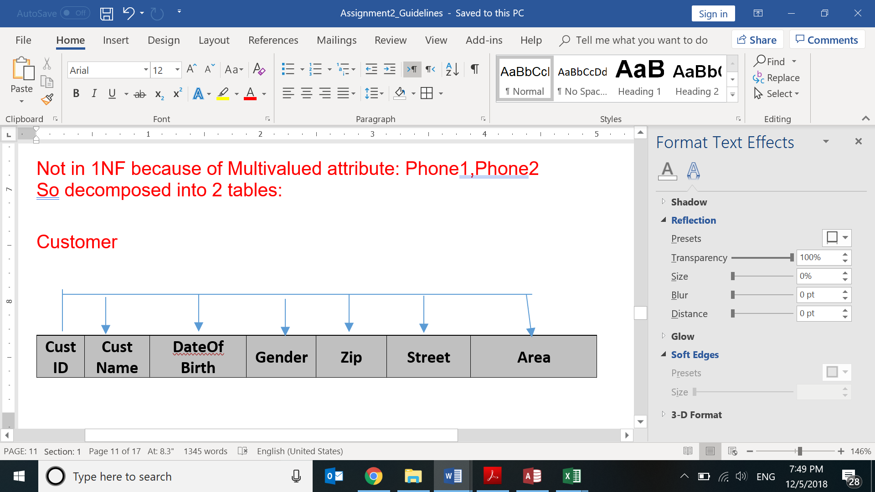

and

Cust_contact:

cust_ID -> Phone 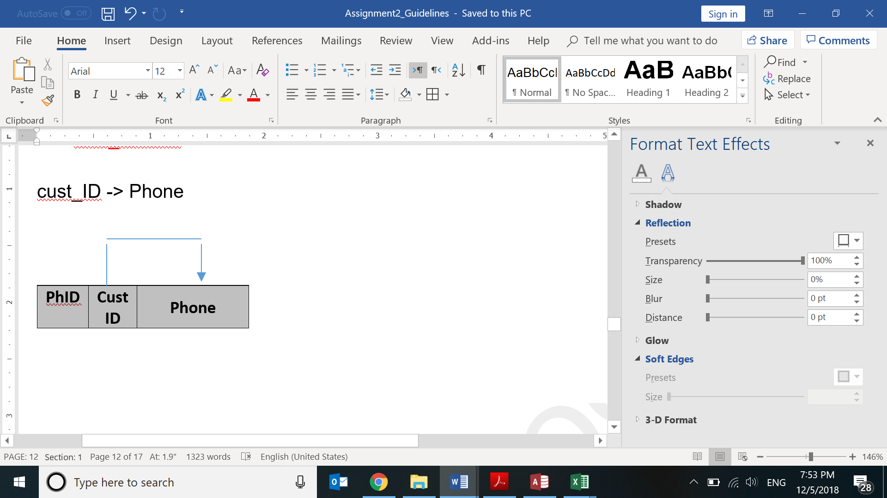

*Do above activity for each NF for each table decomposed in Task* 2.b

*Now take screenshots of each of the tables with data from MSAccess and paste below*

**CustomerTable**

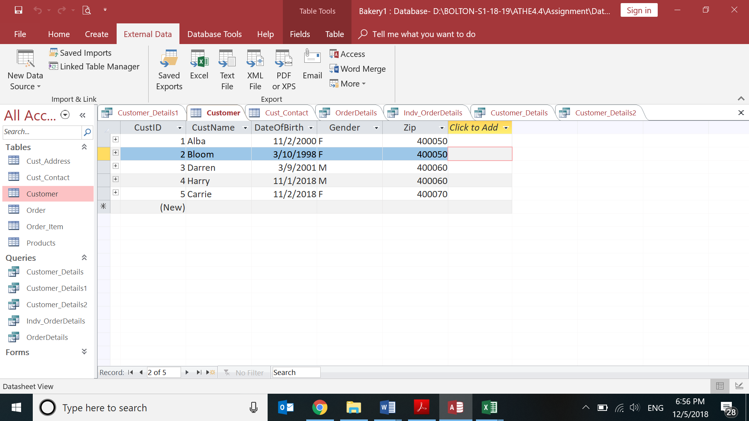

**Customer_Phone table**

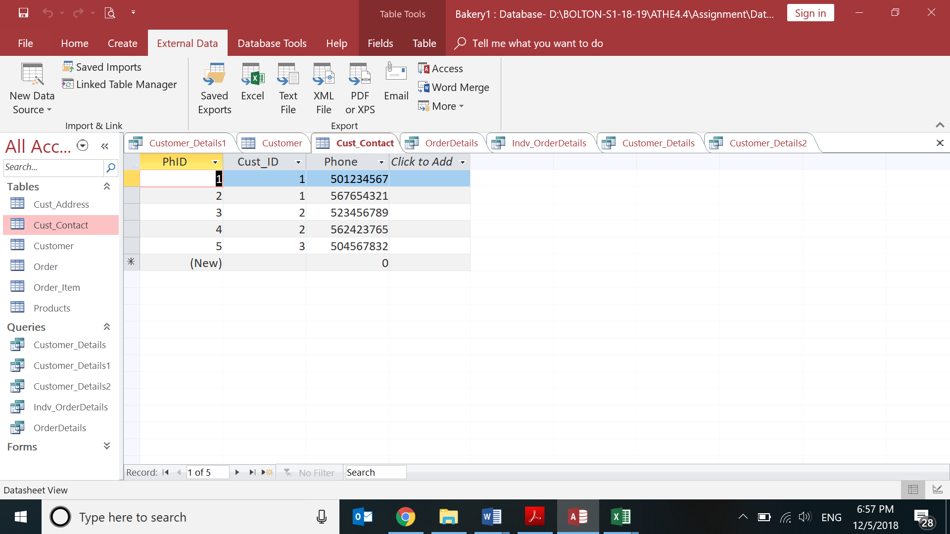

And others

## 3c) Integrity Constraints

*Definition of Integrity Constraint*

*Definition of Types of Integrity Constraint.*

|  |
| --- |
| 3.d) Data integrity and Security controls *Definitions basically of the points described in 2c).*    *PASSWORD PROTECTION SCREENSHOT* |
|  |

## 3e) how the design documents meet the design brief?

*Describe what activities you did: ERD, Normalization, Int constraints, Queries,…..*

*Display Results of Queries:*

1. *CustomerDetails*

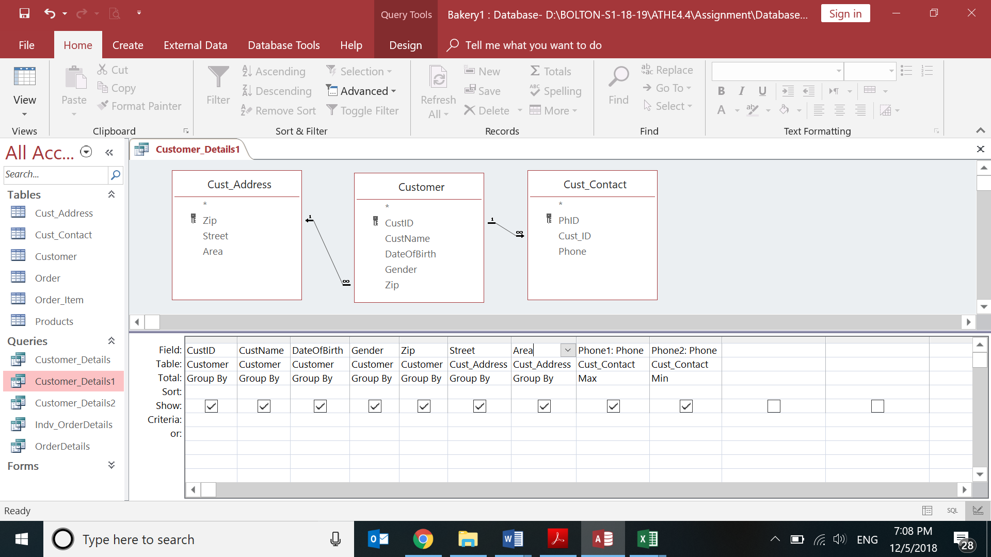

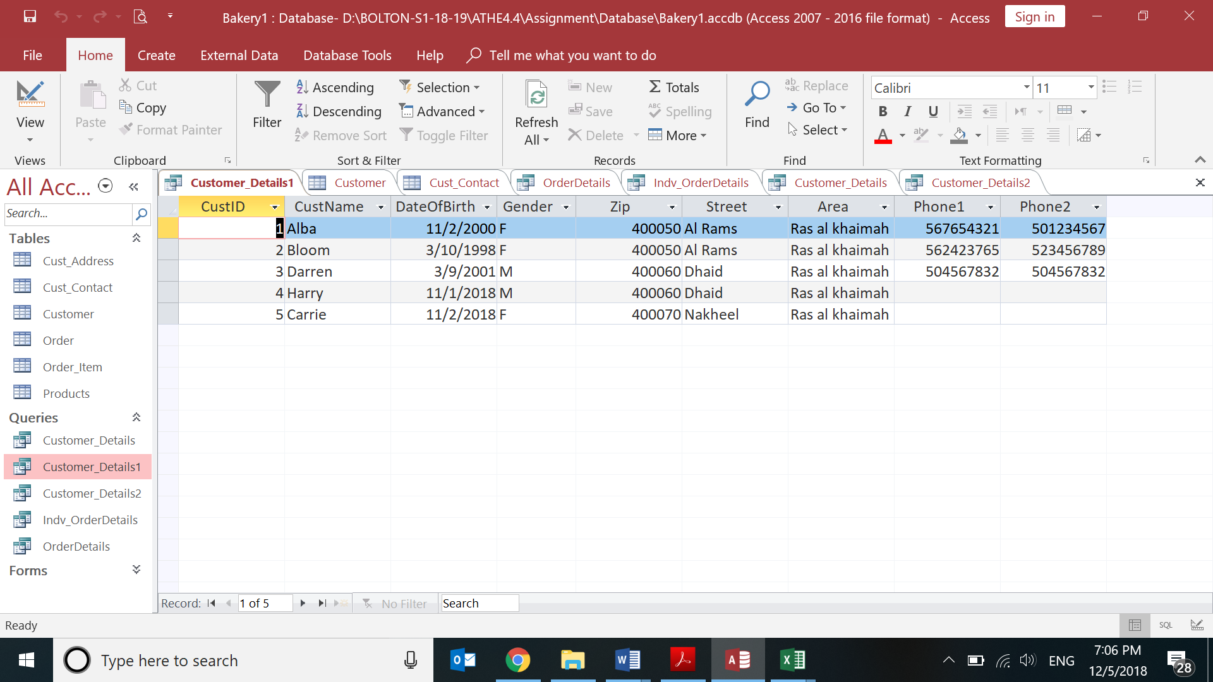

1. *Get Individual order*
2. *Get Cumulative Orders by Customers*

## 3.f) Database Evaluation

*Type the feedback given by Tutor.*

*Then specify that you made the changes accordingly in terms of ERD, Normalization, and other features. (Something like below):*

*The database design has been changed according to the feedback and now been normalized so decomposition has happened, and a new field has been added as well to provide more detail and becomes easier to link up all the tables*

***Design***

***Normalization***

*Customers-The table was decomposed to ……., so 2 new tables are now there*

*Table 2- nothing was changed in this table*

*Tbl 3-A new field was added to link it up with the ***** table as the foreign key*

# References